**GRADE 4- WEEK 3**

**UNIT 1 : They’re from Australia!**

**LESSON 2**

**VOCABULARY**

**Korea: nước Hàn Quốc**

**Viet Nam : nước Việt Nam**

**Mexico: nước Mê-Hi-Cô**

**Thailand: nước Thái Lan**

**Australia: nước Úc**

**The USA: nước Mỹ**

**Brazil: nước Bờ-ra-zin**

**Grammar**

* **The present simple affirmative and negative: be**

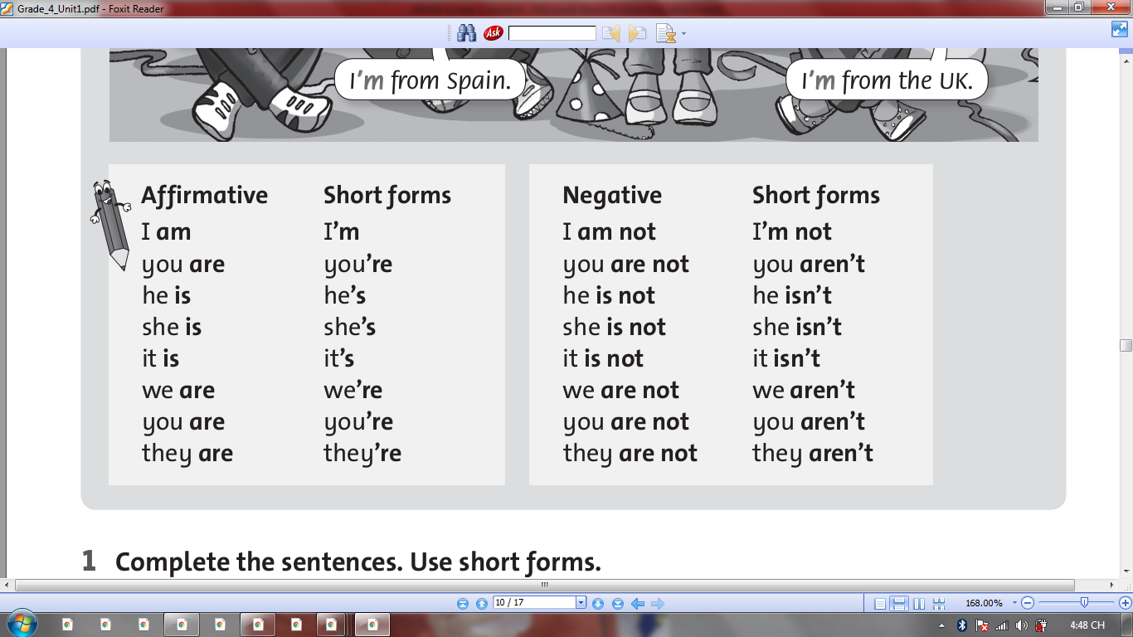

* **The present simple question and short answers: be**

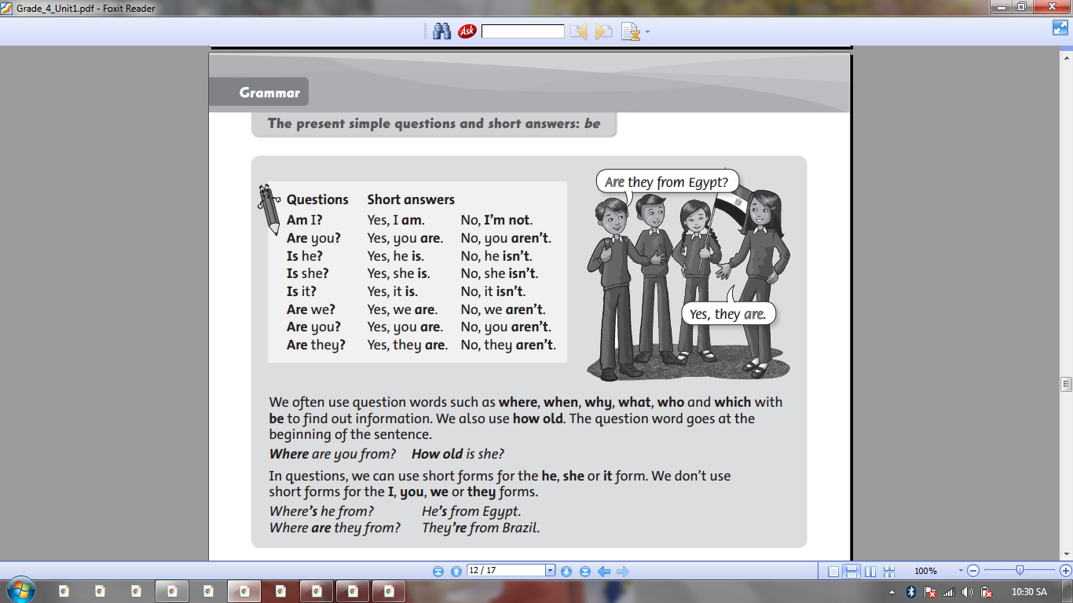

**EXERCISE**

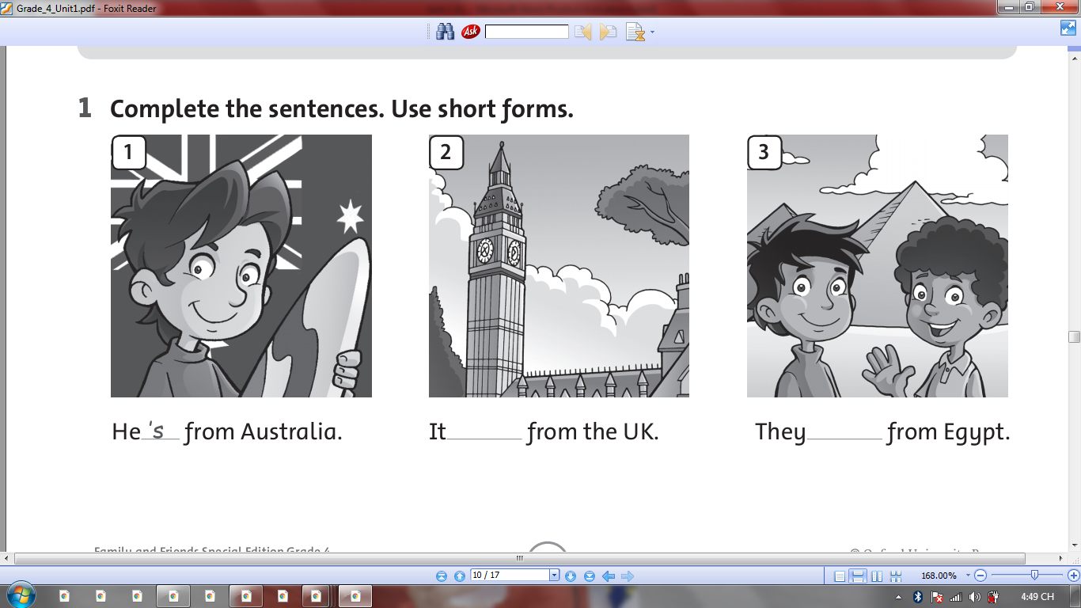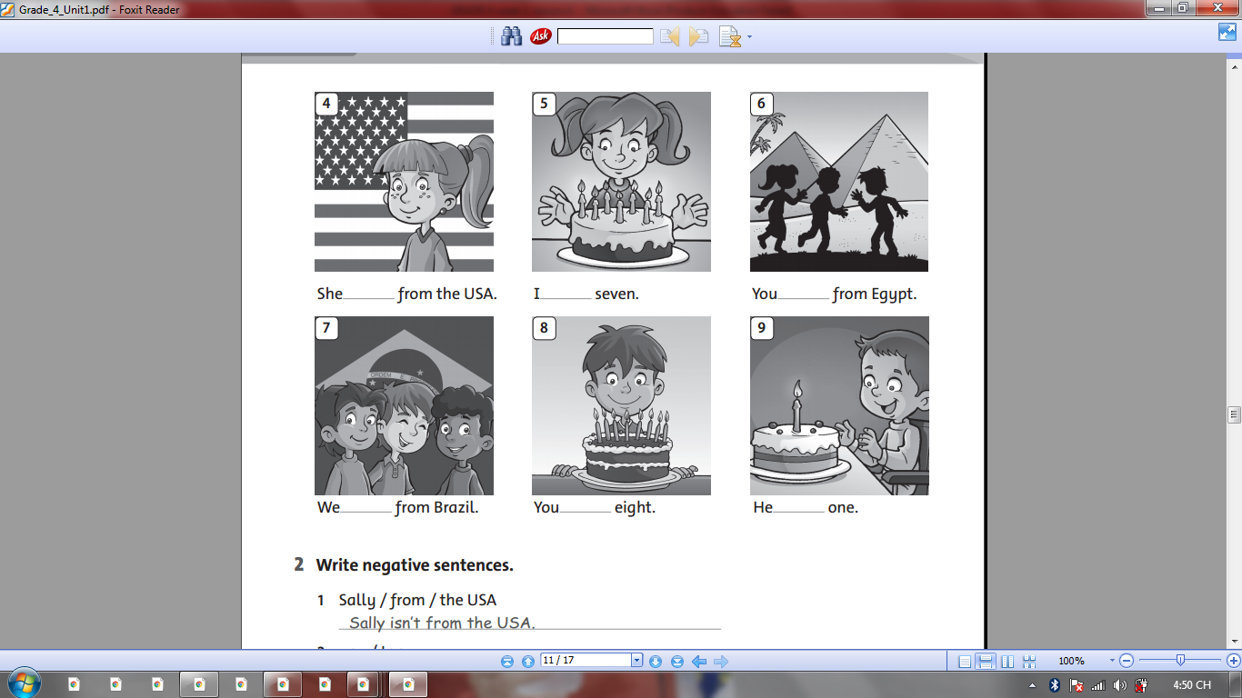

**2.**

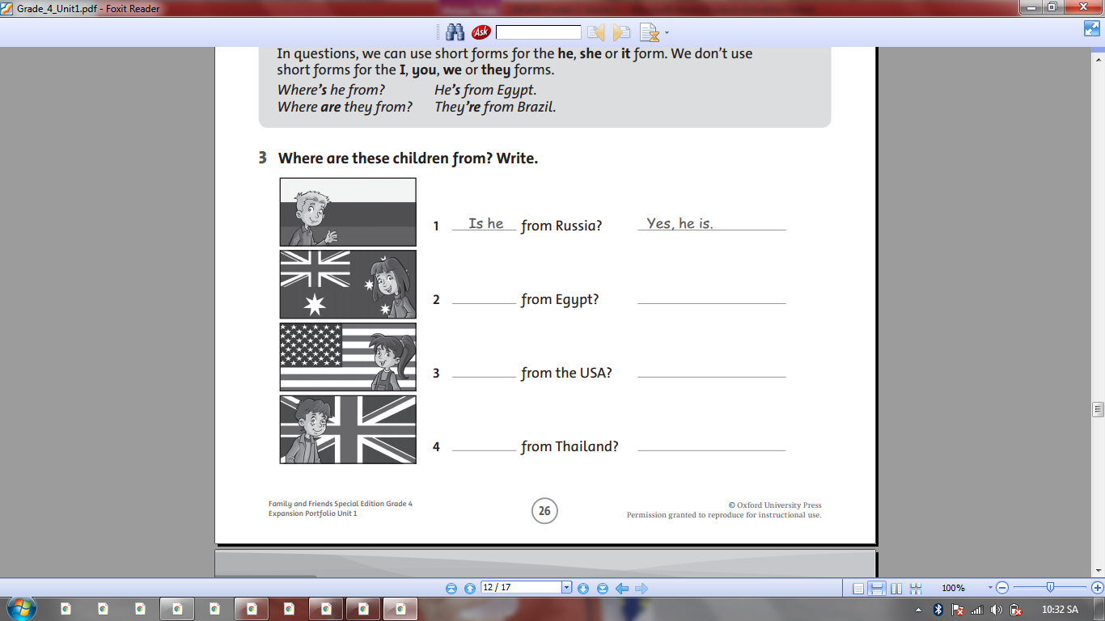

**3.Look and answer the questions**

|  |  |  |
| --- | --- | --- |
| HÃ¬nh áº£nh cÃ³ liÃªn quan | Káº¿t quáº£ hÃ¬nh áº£nh cho Vietnam clipart |  |
| Where are they from ? | Where are they from ? | Where are they from ? |
| **They are from Brazil.** | *………………………………..* | *………………………………..* |
| HÃ¬nh áº£nh cÃ³ liÃªn quan | HÃ¬nh áº£nh cÃ³ liÃªn quan | Káº¿t quáº£ hÃ¬nh áº£nh cho thailand clipart |
| Where is she from ? | Where is he from ? | Where is she from ? |
| *………………………………..* | *………………………………..* | *………………………………..* |
| HÃ¬nh áº£nh cÃ³ liÃªn quan | Káº¿t quáº£ hÃ¬nh áº£nh cho mexico clipart | HÃ¬nh áº£nh cÃ³ liÃªn quan |
| Where is he from ? | Where is he from ? | Where are they from ? |
| *………………………………..* | *………………………………..* | *………………………………..* |

**COPY WORDS**

**Korea ______________________________________________________________________________________________________________________________________________________________________________________________________________________________**

**Vietnam**

**______________________________________________________________________________________________________________________________________________________________________________________________________________________________**

**Mexico**

**______________________________________________________________________________________________________________________________________________________________________________________________________________________________**

**Thailand**

**______________________________________________________________________________________________________________________________________________________________________________________________________________________________**

**Australia**

**______________________________________________________________________________________________________________________________________________________________________________________________________________________________**

**The USA**

**______________________________________________________________________________________________________________________________________________________________________________________________________________________________**

**Brazil ______________________________________________________________________________________________________________________________________________________________________________________________________________________________**